boot sources???
1) NAND Flash
2) NOR Flash (eXecute In place, XIP)
3) USB
4) eMMC
5) SD card
6) Ethernet
6) UART
7) SPI

SYSBOOT[4:0]
“SYSBOOT” is one of the register of this SOC and its first five bits decide the boot order .

When SYSBOOT [4:0] = 00000b (This is reserved, you cannot use this configuration)
When SYSBOOT [4:0] = 00001b
After the RESET if SYSBOOT [4:0] = 00001b , then SOC will try to boot from UART0 first , if fails, then it tries to boot from XIP(XIP stands for eXutable In Place memory like NOR Flash), if that also fails, then it will try to boot from MMC0, if no success, finally it tries to boot from SPI0, if that also fails, then SOC outputs the error message and stops.

How SOC decides the boot order?
When you reset the SOC, the code stored in the ROM of the SOC runs first !
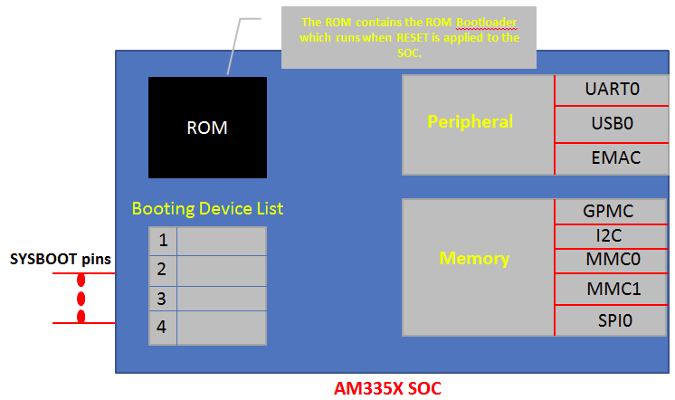

The code stored in the “ROM” is called ROM boot loader, this is programmed in to the ROM of the SOC during taping out of the chip, you cannot able to change it, why?? Because its ROM. Read only !!!!
The job of the ROM is to set up the SOC clock, watch dog timer, etc and also its major job is to load the second stage boot loader, what we call MLO or SPL, more on this later.

second stage boot loader?
For that what ROM code does is, it reads the register SYSBOOT [15:0], and based on the value of SYSBOOT[4:0] it prepares the list of booting devices. The register SYSBOOT [15:0] value is decided by the voltage level on the SYSBOOT pins.
That is, let’s say, if SYSBOOT[4:0] = 00011b, then boot order will be , UART0,SPI0.XIP,MMC0 ( look at the table please !!! )
So, we can say that, The SYSBOOT pins configure the boot device order (set by SYSBOOT[4:0]).
Some board, will give you the control to change the SYSBOOT[15:0] value by using dip switches like below.

Here, by configuring the dip switches you can decide the value of SYSBOOT pins , thus enforcing the boot order which you like.

But in BBB, there are no such dip switches to configure the SYSBOOT pins. BBB has some other circuitry to decide the SYSBOOT pins voltage level, read on!!
BBB Boot order configuration circuit
In BBB you will find this circuitry,
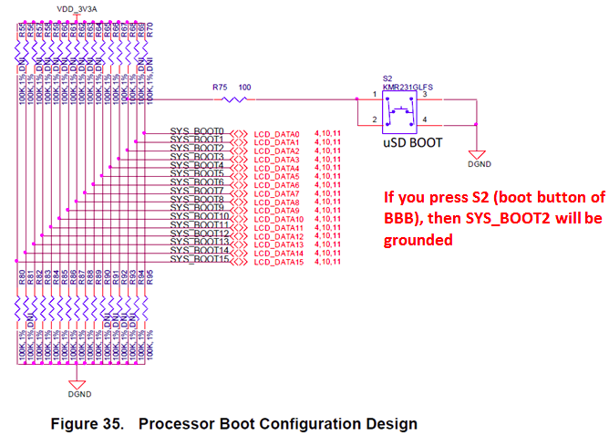

Here observe that SYS_BOOT2 is connected to a button S2 of the BBBB ( S2 is the boot button )

1) S2 Released (SYSBOOT[4:0] = 11100)
The boot order will be
- MMC1 (eMMC)
- MMC0 (SD card)
- UART0
- USB0
2) S2 pressed (SYSBOOT[4:0] = 11000) , The boot order will be
- SPI0
- MMC0 (SD card)
- USB0
- UART0

To conclude, there are 5 boot sources supported for this board including SPI.
1) eMMC Boot(MMC1) :
eMMC is connected over MMC1 interface, This is the fastest boot mode possible, eMMC is right there on your board, so need not to purchase any external components or memory chip. This is the default boot mode. As soon as you reset the board, the board start booting from loading the images stored in the eMMC.
If no proper boot image is found in the eMMC, then Processor will automatically try to boot from the next device on the list.
2) SD Boot :
If the default ( that is booting from eMMC) boot mode fails, then it will try to boot from the SD card you connected to the sd card connector at MMC0 interface.
If you press S2 and then apply the power, then the board will try to boot from the SPI first, and if nothing is connected to SPI, it will try to boot from the MMC0 where our SD card is found
Also remember that we can use SD card boot to flash boot images on the eMMC. So if you want to write new images on the eMMC then you can boot through sd card, then write new images to eMMC, then reset the board, so that your board can boot using new images stored in the eMMC.

3) Serial boot :
In this mode, the ROM code of the SOC will try to download the boot images from the serial port.
4 ) USB BOOT :

when you reset the board, you can make your board to boot from the USB stick.

These are the 2 flow charts, you can find in the TRM of the am335x SOC
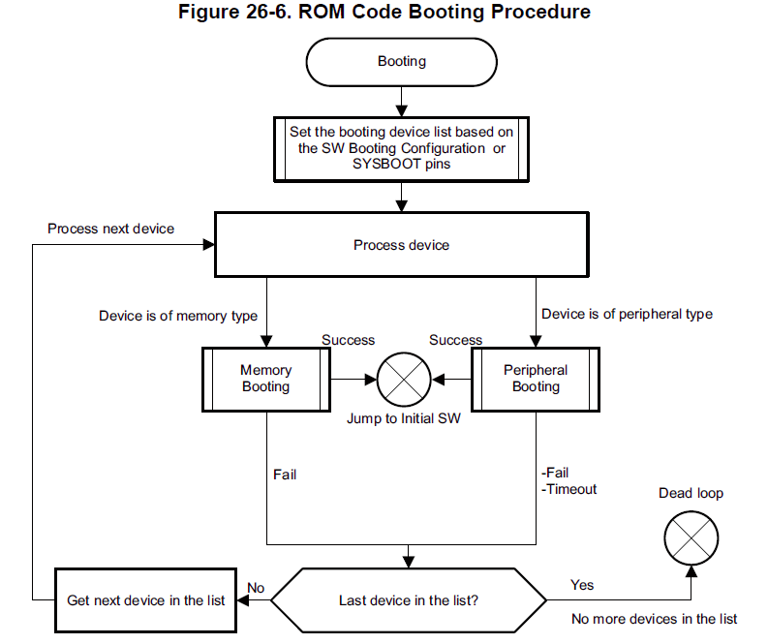

the ROM code goes through its boot device list to load the second stage boot loader. It will prepare the boot devices list based on the value of SYSBOOT pins.

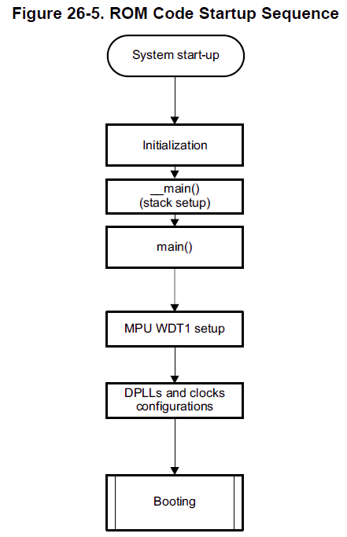

Stack, watchdog, DPLL , clocks.

176 KB ROM
64 + 64 KB RAM

watchdog timer – 3 minutes

RBL must load SPL within this time.

PLL – I/P – 16-24 Mhz
O/P – upto 800 Mhz

RBL

-initialization----> _main() stack setup ------> main() ------> Watch Dog timer setup (for 3 mins, that means, if it cant load SPL within 3 mins, the processor) will be reset ------> Clock setup through PLL (24 MHz crystal oscillator input ----> upto 800 MHz output) -----> Search memory devices for MLO or SPL ------> Copy SPL into the internal SRAM of SoC ----> Execute MLO or SPL.

-Based on value of SYSBOOT[15:14] bits, RBL comes to know about the value of the crystal oscillator connected to SoC
00b - 19.2 MHz
01b - 24 MHz
10b - 25 MHz
11b - 26 Mhz

-On BBB, we have 24 MHz oscillator (Y2)
-MPUADPLLS is locked to provide 500 MHz for the A8
-RBL tries to fetch the SPL from the device list as per the value of SYSBOOT[4:0]
-When/If found, the RBL copies the SPL to the internal RAM (64 kB + 64 kB shared)

-MLO will have its own image header - decided by TI - which contains some info like load address (0x4000 0000),size of the image to follow etc.

-RBL first reads the image header from MLO.

MLO/SPL

-initializes SoC to a point that U-boot (third stage boot) can be loaded into the external RAM (DDR).

Jobs
1. does UART console configuration to print out the debug messages
2. Reconfigures the PLL to desired value.
3. Initializes the DDR registers to use the DDR memory.
4. Does muxing configurations of boot peripherals pin, becuase the next job is to load the U-boot from the boot peripherals
5. If MLO is going to get the u-boot from the MMC0 or MMC1 then it will do the mux configurations to bring out the MMC0 or MMC1
6. Copies the U-boot image to DDR m/y and passes control to it.

-U-boot will also have its image header (load address = 0x8000 0000 and size of the image to follow)

Q) Why cant RBL directly copy U-boot to internal SRAM? Why SPL is loaded?
Ans: Internal SRAM is only 128 kB. Its not possible to squeeze U-boot to this size.

Q) Why cant RBL copy U-boot directly to DDR (external RAM) ?
Ans:
ROM code won’t be having any idea about what kind of DDR RAM being used in the product to initialize it. DDR RAM is purely product/ board specific. RBL has no idea in which product this chip will be used and what kind of DDR will be used, and what are DDR tuning parameters like speed, bandwidth, clock augments, size, etc. Because to read ( or write) anything from/to DDR RAM , first, the tuning parameters must be set properly and DDR registers must be initialized properly. Every different manufacture will have different parameters for their RAM. So, that’s the reason RBL never care about initializing DDR controller of the chip and DDR RAM which is connected to chip. RBL just tries to fetch the SPL found in memory devices such as eMMC and SD card or peripherals like UART,EMAC,etc. And in the SPL/MLO, you should know, what kind of DDR is connected to your product and based on that you have to change the SPL code , rebuild it and generate the binary to use it as the second stage boot loader.

Testing MLO
-download MLO
-Partition the uSD Card into two
Partition 1 - FAT (BOOT) - around 1GB
Partition 2 - Ext3 (ROOTFS)

-Set "boot" flag for BOOT partition
-Copy MLO to BOOT partition
-Eject SD Card and insert to BBB.
-Power the BBB with S2 pressed

Testing U-Boot

- Download U-boot image
-Copy u-boot.img to SD Card
-Insert SD Card to BBB, press S2 and give power

U-Boot

Jobs
1. Initialize some of the peripherals like UART, I2C, NAND, FLASH, ETHERNET, USB, MMC etc. because it supports loading kernel from all these peripherals.
2. Load the Linux kernel image from various boot sources to the DDR memory of the board.
3. Boot Sources: USB, eMMC, SD Card, Ethernet, serial port, NAND flash etc.
4. Passing of boot arguments to the kernel.

Testing U-Boot + Rootfs

-uEnv.txt
- Consists of environment variables values of the u-boot which directs u-boot how to behave

- U-boot always looks for uImage - zImage + U-boot header (64 bytes)
-zImage - ELF
- Append zImage to u-boot header using "mkimage" command

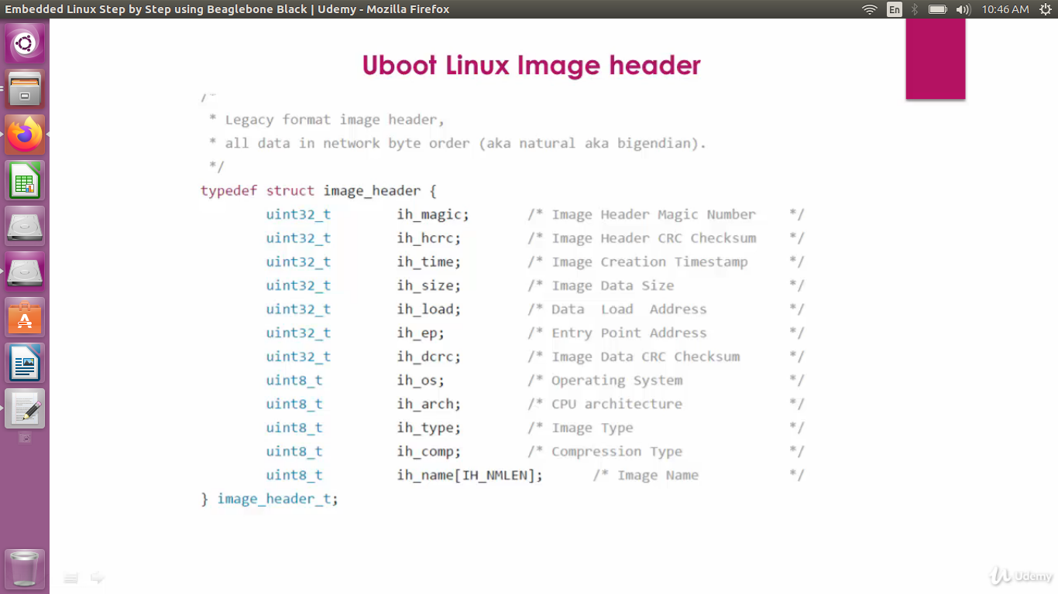

- Download Angstrom rootfs
- Extract the folders
- Copy the folders to ROOTFS partition of the SDCard.
- Add "uEnv.txt" to the BOOT partition

bootcmd environment variable:

The bootcmd environment variable is a set of nested conditional statements.

bootcmd=if mmc init; then if run loadbootscript; then run bootscript; else if run loaduimage; then run mmcboot; else run nandboot; f
i; fi; else run nandboot; fi
The first conditional "if mmc init" checks to see if the SD/MMC card exists. If the card exists, the next conditional "if run loadbootscript" checks to see if the bootscript boot.scr exists on the SD card. If the boot script exists, then it is executed. The boot script contains the boot arguments and the command to actually boot the Linux kernel. So if the bootscript exists and is executed, it should not return to rest of the bootcmd.

U-boot commands
1. Load the uImage from memory device to DDR memory
2. Use the memory dump command of the U-boot to dump header information

While booting, when you see : Hit any key to stop autoboot, press some key, it takes you to U-boot prompt

U-boot#

1) U-boot# help load
- list the usage and option of using load command

load usage:
load <interface> [<dev[:part]> [<addr> [<filename> [bytes [pos]]]]]

2) U-boot# load mmc 0:2 0x82000000 /boot/uImage
-Loads the uImage to DDR

3) U-boot# help md
- memory display command
- Usage: md [.b, .w, .1] address [# of objects]

4) U-boot# md 0x82000000 10
- display the RAM contents
- can manually check the header contents

5) U-boot# help imi
- print header info for application image
- Usage: iminfo addr [addr...]

U-boot Control Flow

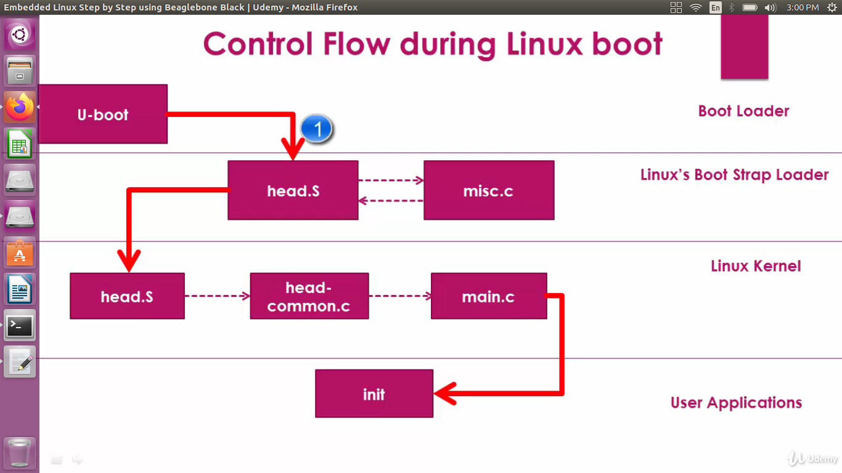

How U-boot hands off the control to bootstrap loader of the Linux Kernel?
- "bootm.c" of U-boot source code
- contains code to read the linux kernel from the memory, verify the checksum, handing off the control is implemented.

1) Linux entry point

kernel_entry = (void (*)(void *fdt_addr, void *res0, void *res1,
void *res2))images->ep;

2) ft_addr is holding the address at which the "Device tree binary" is present in the DDR memory.
- Device tree binary or flattened device tree - binary which describes various peripherals on the board

3) U-boot hands off control to the Kernel's bootstrap loader.
kernel_entry(0, machid, r2);
machid - machine id of the board which is detected by the u-boot, passed to linux via register r1
r2 - address of the DTB present in the DDR RAM. Passed to Linux via register r2

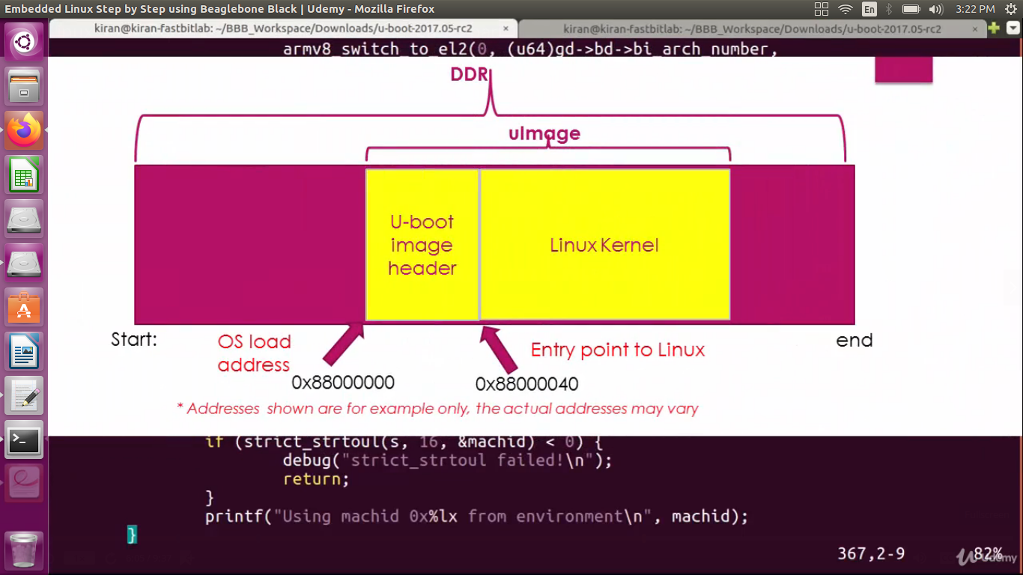

BootStrap Loader
Linux's Boot strap loader consists of
- head.s
- misc.c

$ vi /arch/arm/boot/compressed/head.s

-switch to thumb mode

- Header info
.word _magic_sig @ Magic numbers to help the loader
.word _magic_start @ absolute load/run zImage address
.word _magic_end @ zImage end address
.word 0x04030201 @ endianness flag

- Decompression of the compressed kernel happens in "misc.c"
- It is called from "head.s"
bl decompress_kernel

- Here decompression happens
- Then control goes to "head.s" in folder arch/arm/kernel

-In this file arch/arm/kernel/"head.S" and friends, following things are done:
1. CPU specific initialization
2. checks for valid processor architecture
3. page table inits
4. initialize and prepare MMU for the identified processor architecture
5. Enable MMU to support virtual memory
6. Calls "start_kernel( )" function of the main.c ("Arch" independent code)

In arch/arm/kernel/head.S, you will find,

/*
* Kernel startup entry point.
*
* This is normally called from the decompressor code. The requirements
* are: MMU = off, D-cache = off, I-cache = dont care, r0 = 0,
* r1 = machine nr, r2 = atags or dtb pointer.
*
* This code is mostly position independent, so if you link the kernel at
* 0xc0008000, you call this at __pa(0xc0008000).

-Important Subroutines in the file

1) Check for proper processor architecture type
- Processor architecture specific initialization code in "arch/arm/mm/proc-*.S"
-If successful, MMU is turned on

Linux Kernel Entry

2) start_kernel() is called from arch/arm/kernel/"head-common.s"

/*
* The following fragment of code is executed with the MMU on in MMU mode,
* and uses absolute addresses; this is not position independent.
*
* r0 = cp#15 control register
* r1 = machine ID
* r2 = atags/dtb pointer
* r9 = processor ID
*/

THUMB( ldr sp, [r3, #16] )
str r9, [r4] @ Save processor ID
str r1, [r5] @ Save machine type
str r2, [r6] @ Save atags pointer
cmp r7, #0
strne r0, [r7] @ Save control register values
b start_kernel

In file init/main.c,
- start_kernel ()

- prints linux banner string from init/version.c
/*
* Interrupts are still disabled. Do necessary setups, then
* enable them.
*/
boot_cpu_init();
page_address_init();
pr_notice("%s", linux_banner);
setup_arch(&command_line);

-In init/version.c,
/* FIXED STRINGS! Don't touch! */
const char linux_banner[] =
"Linux version " UTS_RELEASE " (" LINUX_COMPILE_BY "@"
LINUX_COMPILE_HOST ") (" LINUX_COMPILER ") " UTS_VERSION "\n";

-- Back In file init/main.c, start_kernel(void)
- Various other peripheral initializations are done
-Finally, it calls

/* Do the rest non-__init'ed, we're now alive */
rest_init();

- In rest_init(), two kernel threads are created,

pid = kernel_thread(kernel_init, NULL, CLONE_FS);

and

pid = kernel_thread(kthreadd, NULL, CLONE_FS | CLONE_FILES);

-kernel_init thread will get PID 1
-kthreadd will get PID 2

-kernel_init will spawn the first user application init which inherits PID1
-kthreadd will spawn other kernel threads.

- Inside kernel_init()
-init memory is freed. M/y used by the initialization functions so far will be reclaimed, because those functions are no longer nedded and no one will call them.

-After that, run init from one of the following locations:
if (!try_to_run_init_process("/sbin/init") ||
!try_to_run_init_process("/etc/init") ||
!try_to_run_init_process("/bin/init") ||
!try_to_run_init_process("/bin/sh"))
return 0;

eMMC flashing from SD Card

1) Download the latest Debian OS
2) Write the bootable image to the SD Card first
3) Boot the board from SD Card
4) Execute the eMMC flasher script
5) eMMC flasher script will flash all the contents of the SD Card on to the eMMC memory

- Script will first divide the eMMC memory into two partitions called BOOT and ROOTFS
- Then it will format the partitions to create file system FAT and EXT4 respectively
- Then copies the images to the partitions

- Download the latest debian image (compressed) file from http://beagleboard.org/latest-images
- Extract it to get the image
- Copy it to the SDCard (sudo dd if=/path/to/.img of=/dev/mmcblk0 ---- takes around 15 mins
- Unmount and insert the SD Card again.
- Edit boot/uEnv.txt to uncomment the following line:
#cmdline=init=/opt/scripts/tools/eMMC/init-eMMC-flasher-v3.sh
- Save and unmount
- Take out the SDCard and inset to BBB
- Press S2 while giving power so that it boots from SDCard
- Once it boots, it starts flashing the image to eMMC on its own. ---- takes around 20 mins with max time spent to create rootfs
- Once its over, it shuts down power.
- Remove the SDCard and boot normally(no S2) from eMMC. Done!

Setting up Network on BBB

-In BBB,
- edit file /etc/resolv.conf
- add two lines:
nameserver 8.8.8.8
nameserver 8.8.4.4
- add default gateway
$ sudo route add default gw 192.168.7.1 usb0 (PC IP of the network-over-usb connection)
$ sudo route add default gw 192.168.6.1 usb1 (PC IP of the network-over-usb connection)

-On host PC side
- we have to share the internet over wifi with the network-over-usb connections
- enable ip forwarding
- $ sudo cat 1 > /proc/sys/net/ipv4/ip_forward (Permission Denied - file owned by root)
Alternate: 1) $ echo 1 | sudo tee /proc/sys/net/ipv4/ip_forward
2) $ sudo bash -c 'echo 1 > /proc/sys/net/ipv4/ip_forward'

- Change iptables to share internet between wifi and ethernet
$ sudo iptables --table nat --append POSTROUTING --out-interface wlp3s0 -j MASQUERADE (name of wifi interface in place of wlp3s0)
$ sudo iptables --append FORWARD --in-interface enx4006a011f59d -j ACCEPT (name of ethernet interface to share with)

Linux Device Tree

-Flattened Device Tree

-The on-board peripherals which connect to I2C,SPI,SDIO,ETHERNET etc have no capability to announce their existence on the board by themselves to the OS. Also called "Platform devices"

-Not dynamically discoverable
-So OS doesn't know how to connect them.

-USB devices can announce themselves and are dynamically discoverable.

-Platform device details are hard-coded in a file called "board file"

-So create a file my-board-config-file.c which has the function my_board_init(). Inside this function, each platform device can be added to the linux system along with corresponding platform data.

-When a driver for a particular platform device is loaded, the Linux calls the "probe" function of the driver to see if there is any match in its platform database. In the "Probe" function, you can do device initializations.

-Different boards will have different onboard peripherals so each board should have its own board file.

-Linux community wanted to cut off the dependencies of platform device enumeration from the Linux kernel, that is, hard coding of platform device specific details into the kernel.

-Device Tree Source - Instead of hard coding the details to the Linux board file, every board vendor has to come up with a file called DTS.
- DTS file consists of all the details related to the board written using some pre-defined syntaxes. This file consists of data structures which describe all the required peripherals of the board.

-A compiler called DTC compiles these source files to create a binary called DTB (Device Tree Binary) which encodes the details of the hardware.
-So no need to recompile the kernel to add a new device, just recompile the DTS and get new DTB.

-When kernel boots, we have to show the kernel where the DTB resides in the memory. Kernel will load the DTB file and extract all the peripheral detials.

Creating Initramfs

The word "initramfs" is made up of three words "initial" "RAM based" "file system"
This is nothing but a file system hierarchy made to live in the RAM of the device by compressing it, and during booting, Linux mounts this file system as the initial file system.
Using initramfs is optional.

To make the peripherals functional, all the drivers must be loaded in to the kernel space.
And along with the drivers, some peripherals may require the firmware binaries to operate.
With a minimal file system, where you store all your drivers and firmware, and load that FS in to the RAM and ask the Linux to mount that file system during boot. Using kernel boot arguments , you can indicate to kernel that your FS resides in RAM.
When the kernel mounts that file system from RAM, it loads all the required drivers for your product and all the peripherals of your product are ready to operate, because the drivers are in place.
After that you can even get rid of this RAM based file system and use (switch to) some other advanced file system (EXT, FAT) which resides on your other memory devices like eMMC/SD card or even you can mount from the network.
So, basically initramfs embedded into the kernel and loaded at an early stage of the boot process, where it gives all the minimal requirements to boot the Linux kernel successfully on the board just from RAM without worrying about other peripherals. And what you should store in initramfs is left to your product requirements, you may store all the important drivers and firmware, you may keep your product specific scripts, early graphic display logos, etc.
How to keep initramfs in to RAM?
There are 2 ways,
1) You can make initramfs “built in” in to the Linux Kernel during compilation, so when the Linux starts booting , it will place the initramfs in the RAM and mounts as the initial root file system and continues.
2) You can load the initramfs from some other sources in to the RAM of your board and tell the Linux Kernel about it (that is , at what RAM address initramfs is present ) via the kernel boot arguments.

Generating initramfs
Step 1: Download and extract the root file system provided by vendor (TI).
Step 2: Get in to the extracted folder and run the below 2 commands from the “terminal”
$ find . | cpio -H newc -o > ../initramfs.cpio
$ cat ../initramfs.cpio | gzip > ../initramfs.gz
In the first command we are generating a cpio archive and then gz archive.
You will end up with the file “initramfs.gz” which is about 3MB.
STEP 3 : install mkImage command
$ apt-get install u-boot-tools
STEP 4: Make our initramfs , uboot friendly by attaching the uboot header with load address and other info .
$ mkimage -A arm -O Linux -T ramdisk -C none -a 0x80800000 -n "Root Filesystem" -d ../initramfs.gz ../initramfs
Now you will end up with a file “initramfs” which also includes the uboot header and this file we will be used as ram based file system whenever required.

In computing (specifically as regards Linux computing), initrd (initial ramdisk) is a scheme for loading a temporary root file system into memory, which may be used as part of the Linux startup process. initrd and initramfs refer to two different methods of achieving this. Both are commonly used to make preparations before the real root file system can be mounted.

Many Linux distributions ship a single, generic Linux kernel image – one that the distribution's developers create specifically to boot on a wide variety of hardware. The device drivers for this generic kernel image are included as loadable kernel modules because statically compiling many drivers into one kernel causes the kernel image to be much larger, perhaps too large to boot on computers with limited memory. This then raises the problem of detecting and loading the modules necessary to mount the root file system at boot time, or for that matter, deducing where or what the root file system is.[1]
To further complicate matters, the root file system may be on a software RAID volume, LVM, NFS (on diskless workstations), or on an encrypted partition. All of these require special preparations to mount.[2]
Another complication is kernel support for hibernation, which suspends the computer to disk by dumping an image of the entire contents of memory to a swap partition or a regular file, then powering off. On next boot, this image has to be made accessible before it can be loaded back into memory.
To avoid having to hardcode handling for so many special cases into the kernel, an initial boot stage with a temporary root file-system — now dubbed early user space — is used. This root file-system can contain user-space helpers which do the hardware detection, module loading and device discovery necessary to get the real root file-system mounted.

An image of this initial root file system (along with the kernel image) must be stored somewhere accessible by the Linux bootloader or the boot firmware of the computer. This can be the root file system itself, a boot image on an optical disc, a small partition on a local disk (a boot partition, usually using ext2 or FAT file systems), or a TFTP server (on systems that can boot from Ethernet).
The bootloader will load the kernel and initial root file system image into memory and then start the kernel, passing in the memory address of the image. At the end of its boot sequence, the kernel tries to determine the format of the image from its first few blocks of data, which can lead either to the initrd or initramfs scheme.
In the initrd scheme, the image may be a file system image (optionally compressed), which is made available in a special block device (/dev/ram) that is then mounted as the initial root file system.
The driver for that file system must be compiled statically into the kernel.

Many distributions originally used compressed ext2 file system images, while the others (including Debian 3.1) used cramfs in order to boot on memory-limited systems, since the cramfs image can be mounted in-place without requiring extra space for decompression. Once the initial root file system is up, the kernel executes /linuxrc as its first process;[4] when it exits, the kernel assumes that the real root file system has been mounted and executes /sbin/init to begin the normal user-space boot process.

In the initramfs scheme (available since the Linux kernel 2.6.13), the image may be a cpio archive (optionally compressed). The archive is unpacked by the kernel into a special instance of a tmpfs that becomes the initial root file system. This scheme has the advantage of not requiring an intermediate file system or block drivers to be compiled into the kernel.
In the initramfs scheme, the kernel executes /init as its first process that is not expected to exit.

Root File System
Now the root file system, as the name indicates, it’s a file system which Linux mounts to the "/" (root)
File system is nothing but a collection of files organized in standard folder structure.
There is a standard for the Linux file system. That is called "File system Hierarchy Standard"

The official documentation of the FHS says this about the directories present in the "/"

U-Boot commands + uEnv.txt
-U-Boot commands

1) help
-will list out all commands available

All commands

? - alias for 'help'
askenv - get environment variables from stdin
base - print or set address offset
bdinfo - print Board Info structure
boot - boot default, i.e., run 'bootcmd'
bootd - boot default, i.e., run 'bootcmd'
bootefi - Boots an EFI payload from memory
bootelf - Boot from an ELF image in memory
bootm - boot application image from memory
bootp - boot image via network using BOOTP/TFTP protocol
bootvx - Boot vxWorks from an ELF image
bootz - boot Linux zImage image from memory
btrsubvol - list subvolumes of a BTRFS filesystem
cmp - memory compare
coninfo - print console devices and information
cp - memory copy
crc32 - checksum calculation
dfu - Device Firmware Upgrade
dhcp - boot image via network using DHCP/TFTP protocol
dm - Driver model low level access
echo - echo args to console
editenv - edit environment variable
eeprom - EEPROM sub-system
env - environment handling commands
exit - exit script
ext2load - load binary file from a Ext2 filesystem
ext2ls - list files in a directory (default /)
ext4load - load binary file from a Ext4 filesystem
ext4ls - list files in a directory (default /)
ext4size - determine a file's size
ext4write - create a file in the root directory
false - do nothing, unsuccessfully
fastboot - run as a fastboot usb or udp device
fatinfo - print information about filesystem
fatload - load binary file from a dos filesystem
fatls - list files in a directory (default /)
fatmkdir - create a directory
fatrm - delete a file
fatsize - determine a file's size
fatwrite - write file into a dos filesystem
fdt - flattened device tree utility commands
fstype - Look up a filesystem type
go - start application at address 'addr'
gpio - query and control gpio pins
gpt - GUID Partition Table
help - print command description/usage
i2c - I2C sub-system
iminfo - print header information for application image
imxtract - extract a part of a multi-image
itest - return true/false on integer compare
load - load binary file from a filesystem
loadb - load binary file over serial line (kermit mode)
loads - load S-Record file over serial line
loadx - load binary file over serial line (xmodem mode)
loady - load binary file over serial line (ymodem mode)
loop - infinite loop on address range
ls - list files in a directory (default /)
md - memory display
mdio - MDIO utility commands
mii - MII utility commands
mm - memory modify (auto-incrementing address)
mmc - MMC sub system
mmcinfo - display MMC info
mw - memory write (fill)
nfs - boot image via network using NFS protocol
nm - memory modify (constant address)
part - disk partition related commands
ping - send ICMP ECHO_REQUEST to network host
printenv - print environment variables
pxe - commands to get and boot from pxe files
reset - Perform RESET of the CPU
run - run commands in an environment variable
save - save file to a filesystem
saveenv - save environment variables to persistent storage
setenv - set environment variables
setexpr - set environment variable as the result of eval expression
sf - SPI flash sub-system
showvar - print local hushshell variables
size - determine a file's size
sleep - delay execution for some time
source - run script from memory
spl - SPL configuration
sspi - SPI utility command
sysboot - command to get and boot from syslinux files
test - minimal test like /bin/sh
tftpboot - boot image via network using TFTP protocol
time - run commands and summarize execution time
true - do nothing, successfully
usb - USB sub-system
usbboot - boot from USB device
version - print monitor, compiler and linker version

-U-Boot Environment variables
- set to standard as well as user defined environmental variables
- can store commands as value

-#printenv variable
-#setenv variable 'value'

-run <environment variable>
will run a environment variable having some commands as its value
eg: run bootcmd
run findfdt

uEnv.txt contains collection of various environment variables set to different commands and automating command execution

- #boot
- runs "bootcmd" environmental variables
- command tries to load kernel and execute it

#bootm
- boot from memory

-U-boot always try to read uEnv.txt from the boot source, if not found, it will use the default values of the environmental variables
- It first reads and loads the Linux kernel to DDR memory
- Then it reads and loads the DTB to DDR memory
- Executes Linux kernel

#fatload
-To load a file from FAT based file system to memory
-eg: #fatload usb 0:1 0x82000000 uImage
-eg: #fatload mmc 0:1 0x88000000 initramfs
-Usage: fatload <interface> [<dev[:part]> [<addr> [<filename> [bytes[pos]]]]]

#load
-To load a file from any file system
-eg: #load mmc 0:1 0x88000000 uImage
-Usage: load <interface> [<dev[:part]> [<addr> [<filename> [bytes[pos]]]]]

Step1
Load the linux kernel image to the DDR m/y from eMMC.
#load mmc 1:2 0x82000000 /boot/uImage

vmlinuz-4.14.108-ti-r113

Step2
Load the device tree binary to the DDR m/y from eMMC
#load mmc 1:2 0x88000000 /boot/am335x-boneblack.dtb

#bootm 0x82000000 - 0x88000000

-BBB uses UART0 as the serial debug terminal which is enumerated as /dev/ttyO0 by the serial driver
-Root filesystem is present in partition2, if that info is not given, we will get log message kernel panic

Step3
Send bootargs to the linux kernel from U-boot
"bootargs" - env variable
#setenv bootargs console=ttyO0,115200 rootfs=/dev/mmcblk0p2 rw

Automating the boot process using uEnv.txt

Booting using Serial port
U-boot's serial port transfer protocols commands
1) loadx - send/receive file using xmodem protocol
2) loady - send/receive file using ymodem protocol
3) loadz - send/receive file using zmodem protocol

-transferring the boot images from HOST PC to the board via serial port(UART) in order to boot the board.
- protocols we can use include:
Xmodem
Ymodem
Zmodem
Kermit etc.
-We have to keep SPL,U-boot, linux kernel image, DTB and the file system on the host PC.

-Booting from UART
When S2 is pressed, boot order is SPIO--->MMC0--->USB0--->UART0
When no image is found in first 3 sources, it checks for UART0

-USB0 is P4 - mini USB cable, so dont use that, give power using adapter (explained in TRM - USB boot)
Errata Note: The system is delayed upto 4.5 minutes before continuing to next boot device if an attempt to boot from Ethernet fails for any reason.

-Peripheral booting
The ROM code can boot from three different peripheral interfaces.
EMAC:1000/100/10Mbps Ethernet,using standardTCP/IP network boot protocols BOOTP and TFTP
USB:Full speed,clientmode
UART:115.2Kbps,8 bits, no parity,1 stop bit, no flow control

-UART boot procedure
Device Initialization
UART boot uses UART0.
UART0 is configured to run at 115200 baud,8-bits,no parity,1 stop bit and no flow control.
Boot Image Download
UART boot uses x-modem client protocol to receive the bootimage.

In minicom,
Ctrl+A, s – to select and send files.
- Once SPL image is received, it is placed into the internal RAM of the SoC.
- executes SPL
- now it tries to get the third stage bootloader (U-boot) over UART0 using Xmodem protocol.
- when u-boot executes, we can use u-boot commands such as xmodem or ymodem to load rest of the images like linux kernel image, DTB, initramfs into the DDR memory of the board at recommended addresses.

-Recommended addresses
Kernel (uImage) - 0x82000000
DTB - 0x88000000
Initramfs - 0x88080000

Steps
1) Power on the board with S2 pressed, no SDCard and no USB Cable
2) Transfer spl
3) Transfer uboot.img
4) Press space to get into uboot prompt
=>loadx 0x82000000
- transfer uImage file
5)
=>loadx 0x88000000
- transfer DTB file
6)
=>loadx 0x88080000
- transfer initramfs file
7)
=>setenv bootargs console=ttyO0,115200 root=/dev/ram0 rw initrd=0x88080000

8) bootm ${kernel_load_address} ${initramfs_load_address} ${dtb_load_address}
=>bootm 0x82000000 0x88080000 0x88000000

Minicom Shortcut keys

To send a file => ctrl+A, then S
To change directory => ctrl+A, then O
To echo on/off => ctrl+A, then E

TFTP Booting

Trivial File Transfer Protocol

SD Card contains,
SPL
u-boot.img
uEnv.txt

In host system, folder /var/lib/tftpboot contains
uImage
Initramfs
DTB

uEnv.txt contains all the commands to automate the process of TFTP boot.

-boot the board via SDCard upto U-boot
-U-boot reads uEnv.txt and executes the TFTP commands to fetch and place the various boot images from tftp server onto the DDR memory.
-command u-boot to boot from the location where it placed the linux kernel image on the DDR memory.

Setting up a TFTP server on Ubuntu host

Step 1: First on your Ubuntu host run the below command using your terminal program.

This command installs the tftpd , xinetd(eXtended InterNET Daemon) . tftpd is a server for the Trivial File Transfer Protocol.

$ sudo apt-get install xinetd tftp tftpd

Step 2 : Create/Open the file “tftp” in the below directory

$ sudo vi /etc/xinetd.d/tftp and put the below entry in to this file and save it

service tftp
{
protocol = udp
port = 69
socket_type = dgram
wait = yes
user = nobody
server = /usr/sbin/in.tftpd
server_args = /var/lib/tftpboot -s
disable = no
}

Step3 :

Create a folder /var/lib/tftpboot and execute below commands

$sudo mkdir /var/lib/tftpboot

$sudo chmod -R 777 /var/lib/tftpboot

$sudo chown -R nobody /var/lib/tftpboot

Step 4: Restart the xinetd service. Now the xinetd daemon is running.

$ sudo /etc/init.d/xinetd restart

Keep the required files in /var/lib/tftpboot

-Change the ip address of ethernet interface on host pc to 192.168.27.1

-Boot the board from eMMC
-Get into U-boot prompt and execute the following commands
=>setenv serverip 192.168.7.1

=>setenv ipaddr 192.168.7.2

Syntax: tftpboot {kernel_load_address} {image_name}
=>tftpboot 0x82000000 uImage

=>tftpboot 0x88000000 am335x-boneblack.dtb

=>tftpboot 0x88080000 initramfs

=>setenv bootargs console=ttyO0,115200 root=/dev/ram0 rw initrd=0x88080000

Syntax: bootm ${kernel_load_address} ${initramfs_load_address} ${dtb_load_address}
=>bootm 0x82000000 0x88080000 0x88000000

Advantages of TFTP boot:
1) Fast transfer of files from Host PC to development board
2) During your development if you keep changing your boot binaries or file system, then tftpboot procedure will save lots of time related to transfer of those images for files to the board for testing.
3) can automate tftpboot using uboot's uEnv.txt

To copy a file from source (HOST) to destination (BBB)
-In the host, keep the file in /var/lib/tftpboot
-On BBB, $ tftp -r {remote_filename} -g {tftp_server_addr}

uEnv.txt examples

serverip=192.168.11.200
ipaddr=192.168.11.230
ramboot=setenv bootargs console=ttyO0,115200n8 root=/dev/ram0 rw ramdisk_size=16384 initrd=0x81000000,16M rootfstype=ext2
uenvcmd=run ramboot;fatload mmc 0:1 81000000 rd-ext2.bin; fatload mmc 0:1 80200000 uImage-epid; fatload mmc 0:1 82000000 am335x-boneblack-epid.dtb; bootm 0x80200000 – 0x82000000;

mmcargs=setenv bootargs console=ttyO0,115200n8 root=/dev/mmcblk0p2 rootfstype=ext2 rootwait
loadfdt=ext2load mmc ${mmcdev}:2 ${fdtaddr} /boot/${fdtfile};
loaduimage=ext2load mmc 0:2 ${loadaddr} /boot/zImage;
uenvcmd=run loaduimage;run loadfdt; run mmcargs; bootz ${loadaddr} - ${fdtaddr};

mmcroot=/dev/mmcblk0p2 rw;
mmcrootfstype=ext2 rootwait;
uenvcmd=run loaduimage;run loadfdt; run mmcargs; bootz ${loadaddr} - ${fdtaddr};
loadfdt=ext2load mmc ${mmcdev}:2 ${fdtaddr} /boot/dtbs/${fdtfile};
loaduimage=ext2load mmc 0:2 ${loadaddr} /boot/zImage;

console=ttyO0,115200n8
ipaddr=192.168.7.3
serverip=192.168.7.1
fdtaddr=0x88000000
absolutepath=/var/lib/tftpboot/
loadtftp=echo Booting from network...;tftpboot ${loadaddr} uImage; tftpboot ${fdtaddr} am335x-boneblack.dtb
netargs=setenv bootargs console=${console} root=/dev/nfs rw rootfstype=nfs ip=${ipaddr} nfsroot=192.168.7.1:/srv/nfs/bbb/,vers=4,tcp ip =dhcp,nolock,wsize=1024,rsize=1024 rootwait rootdelay=5
uenvcmd=setenv autoload no; run loadtftp; run netargs; bootm ${loadaddr} - ${fdtaddr}

U-Boot source code

-Uboot source folder

- /board/ti/am335-x folder has the board specific initialization source files for BBB.
- The processor specific initializations are found in arch/arm/cpu/
- armv7 folder for BBB.
- Start.s can be found here - where RBL hands over to SPL
- Folder config/
- default configuration files - basic and required functionalities/configurations
- am335-x_boneblack_defconfig

Cross-Compile toolchain Installation

STEP1
Download arm cross toolchain for host machine
-link : https://releases.linaro.org/components/toolchain/binaries/7.4-2019.02/
-folder : arm-linux-gnueabihf
-file : gcc-linaro-7.4.1-2019.02-x86_64_arm-linux-gnueabihf.tar.xz

STEP2
Export path of the cross-compilation toolchain
- $ export PATH=$PATH:/path/to/bin_folder
- $ export PATH=$PATH:/home/you2brutus/Documents/gcc-linaro-7.4.1-2019.02-x86_64_arm-linux-gnueabihf/bin
- Append the command to ~/.bashrc : export PATH=$PATH:/home/you2brutus/Documents/gcc-linaro-7.4.1-2019.02-x86_64_arm-linux-gnueabihf/bin
- In terminal type: $source ~/.bashrc

SPL and U-Boot Compilation

Step1
distclean : deletes all the previously compiled/generated object files.
$ make ARCH=arm CROSS_COMPILE=arm-linux-gnueabihf- distclean

Step2
Apply board-default configuration for U-boot
$ make ARCH=arm CROSS_COMPILE=arm-linux-gnueabihf- am335x_boneblack_defconfig
- configuration will be written to .config

Step3
Change configurations by running menuconfig
$ make ARCH=arm CROSS_COMPILE=arm-linux-gnueabihf- menuconfig

Step4
Compile
$ make ARCH=arm CROSS_COMPILE=arm-linux-gnueabihf- -j4

- -jN(no of cores) - to create N threads on N cores of host processor

Note: First spl.bin was created by build then ran a command "mkimage" on spl.bin to generate MLO

Linux Compilation

-Architecture specific Code organization in linux:
Architecture Dependednt : Board File, machine(SoC) shared common code, ARM CPU shared common code
Architecture Independent : Linux kernel shared common code

-arch/arm folder
processor specific, board specific and SoC specific details

Arm code organization in Linux:
- CPU specific Code folders
arch/arm/kernel
arch/arm/mm
arch/arm/boot/compressed
arch/arm/boot/lib
- Board ans SoC specific code
arch/arm/mach-XXXXXXXX (XXXXX-omap2 in case of AM335x)
-The board file is a C source file which explains the various peripherals on the board (outside SoC). This file usually contains the registration functions and data of various onboard devices eg for Ethernet PHY, EEPROM, LEDs, LCDs etc. Basically the board vendor uses this board file to register various board peripherals with the Linux subsystem.
eg: arch/arm/mach-omap2/(board-omap3beagle.c,board-omap3pandora.c etc.)

-The machine shared common code contains various C source files which contain the helper functions to initialize and deal with the various onchip peripherals of the SoC and these codes are common among all the SoCs which share common IP for the peripherals.
eg: arch/arm/mach-XXX/(serial,gpio,common,clocks,display etc)

-Nowadays, most of the board files are removed and "board-generic" has been introduced which is generic to all the boards based on OMAP2 + SoCs, thanks to DTB. The filed called ".dt_compat". Linux compares the field in DTB with the ones in board-generic file.

Driver code organization
-kept in drivers/ folder
-eg: LCD Driver - drivers/video/fbdev
Touch Screen Controller - drivers/input/touchscreen/ti_tsc.ko
SD/MMC/SDIO - drivers/mmc/host/omap_hsmmc.c
SPI - drivers/spi/spi-omap2-mcspi.c
I2C - drivers/i2c/busses/i2c-omap.c
GPMC - drivers/memory/omap-gpmc.c

Step 1
distclean
$ make ARCH=arm CROSS_COMPILE=arm-linux-gnueabihf- distclean

Step2
Apply default configuration
$ make ARCH=arm CROSS_COMPILE=arm-linux-gnueabihf- bb.org_defconfig

Step3
Change configurations by running menuconfig
$ make ARCH=arm CROSS_COMPILE=arm-linux-gnueabihf- menuconfig

Step4
Compile, specify output name (uImage), instruct to generate dtb, provide load address of uImage
$ make ARCH=arm CROSS_COMPILE=arm-linux-gnueabihf- uImage dtbs LOADADDR=0x80008000 -j4
Output - uImage, dtb

Step5
Build the modules - dynamically loadable kernel modules are not yet compiled, compile them separately
$ make ARCH=arm CROSS_COMPILE=arm-linux-gnueabihf- modules -j4
Output - module_names.ko

Step6
Install modules in the rootfs. Generated .ko files should be transferred to Root File System. "Module Installation"
$ make ARCH=arm CROSS_COMPILE=arm-linux-gnueabihf- INSTALL_MOD_PATH=<path of the RFS> modules_install

Busybox
Busybox - tool for creating customized File System

-It enables to create customized file system that meets your resource requirements.
-can fit your FS into limited memory space
-unwanted features can be removed
-can significantly reduce the memory consumed by various commands by merging all the Linux commands in one single binary.

-In Ubuntu PC, all commands together consume more than 200MB. (/bin + /sbin + /usr/bin + /usr/sbin)
-Busybox supports most of the commands that you can find in /bin and /sbin of your PC with very minimal memory footprint.

-Busybox has only one single executable binary called "busybox" - contains support for all the commands
-implemented like a switch case of commands

From website:
BusyBox combines tiny versions of many common UNIX utilities into a single small executable. It provides replacements for most of the utilities you usually find in GNU fileutils, shellutils, etc. The utilities in BusyBox generally have fewer options than their full-featured GNU cousins; however, the options that are included provide the expected functionality and behave very much like their GNU counterparts. BusyBox provides a fairly complete environment for any small or embedded system.

BusyBox has been written with size-optimization and limited resources in mind. It is also extremely modular so you can easily include or exclude commands (or features) at compile time. This makes it easy to customize your embedded systems. To create a working system, just add some device nodes in /dev, a few configuration files in /etc, and a Linux kernel.

Busybox Compilation
Step1
Download source code from https://busybox.net/downloads/
-Extract

Step2
Apply the default configurations
$ make ARCH=arm CROSS_COMPILE=arm-linux-gnueabihf- defconfig

Step3
Change any settings if required using menuconfig
$ make ARCH=arm CROSS_COMPILE=arm-linux-gnueabihf- menuconfig
-building in static way : Settings---->Build static binary

Step4
Building the binary
$ make ARCH=arm CROSS_COMPILE=arm-linux-gnueabihf- CONFIG_PREFIX=<install_path> install

-Three folders are created - bin, sbin, usr. All the files (commands) in bin and sbin, usr/bin and usr/sbin point to busybox file in bin folder.

- Install modules in the rootfs. Generated .ko files should be transferred to Root File System. "Module Installation"
$ make ARCH=arm CROSS_COMPILE=arm-linux-gnueabihf- INSTALL_MOD_PATH=<path of the RFS> modules_install
- Should be executed from linux kernel folder from linux compilation was executed
-<path of RFS> shoulde be the folder in which RFS was installed

- A new folder lib will be created in RFS folder
- lib/modules/<kernel version>/modules.builtin - list all the statically loaded kernel modules
- lib/modules/<kernel version>/modules.dep - list of dependencies for dynamically loaded kernel modules
- When $ modprobe <module.ko> - command is used, it checks the modules.dep file for dependencies and loads them first.
- When $ insmod - command is used, it just tries to load the module without checking for dependencies

NFS
NFS stands for Network File System. This tutorial is going to show you how to configure NFS share on Ubuntu 16.04 so that other computes in your local network can access files and directories on the Ubuntu 16.04 system. We will see how to configure the server side and the client side.
NFS allows directories and file systems to be shared across a local network. NFS can also be set up over the Internet but it’s not secure. In this tutorial, we will set up NFS file share in a home network with two Ubuntu 16.04 computers.
Step 1: Configure the NFS Server
On the first Ubuntu 16.04 computer, install nfs-kernel-server packages.
$sudo apt install nfs-kernel-server
Then edit the exports file with nano text editor. The exports files tell NFS server which directories or file systems will be shared to client.
$ sudo nano /etc/exports

The syntax is as follows:
/path/to/directory client-IP address(options)
For example, you want to share you home directory to the second Ubuntu computer with IP address 192.168.1.101, then put the following line at the end of the file. Replace username with your actual username. Delimit the two columns with Tab key.
/home/username 192.168.1.101(rw,sync,root_squash,subtree_check)
Press Ctrl+O to save the file, then CTRL+X to exit out of the file. The IP address of the client computer can be found by running the following command on the client side.
ifconfig

Step 2: Configure the Client
On the second Ubuntu computer, install nfs-common package.
$ sudo apt install nfs-common
Then edit /etc/fstab file.
$ sudo nano /etc/fstab
Add the following line in the file. Replace nfs-server-ip with the IP address of the first Ubuntu computer.
nfs-server-ip:/home/username /mnt/nfs-share nfs rw,soft,intr,noatime,x-gvfs-show

The above line will mount the home directory under /mnt/nfs-share directory in read and write mode. x-gvfs-show option will let you see the shared directory in your file manager.
Save and close the file. Then create the mount point.

$ sudo mkdir /mnt/nfs-share
Next, run the below command
$ sudo mount -a
Now you can access the server’s home directory in your file manager.

If you want to share your home directory with all computers in your home network, then add this line in /etc/exports file, supposing 192.168.1.1 is the IP address of your router.

/home/username 192.168.1.0/24(rw,sync,root_squash,subtree_check)
If you make any changes to /etc/exports file on the server side, then run the below command to tell NFS server to re-read /etc/exports file.
$ sudo exportfs -ra

Buildroot
Buildroot is a simple, efficient and easy-to-use tool to generate embedded Linux systems through cross-compilation.

